|  |
| --- |
| SFU |
| STAT 485 Assignment 3 |
| Kun Yang 301178299 |

|  |
| --- |
|  |

> rm(list = ls())

> AR1=arima.sim(list(order=c(1,0,0),ar=0.7),n=100)

> plot(AR1,ylim=c(-5,5),col="red",ylab="x",main=(expression(AR(1)~~~phi==+0.7)))

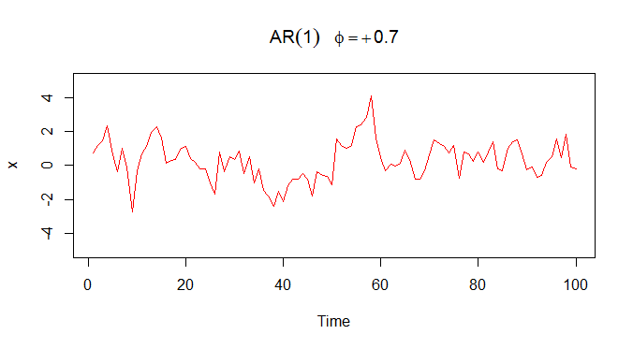

> MA1=arima.sim(list(order=c(0,0,1), ma=0.4), n=100)

> plot(MA1,ylim=c(-5,5),col="blue",ylab="x",main=(expression(MA(1)~~~theta==+0.4)))

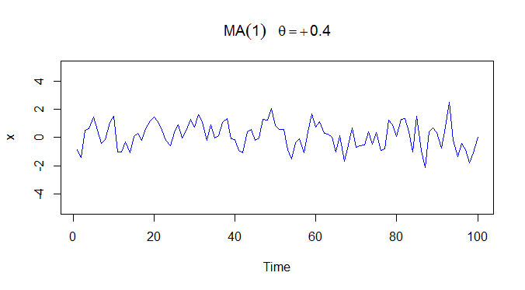

> ARMA1=arima.sim(list(order=c(1,0,1),ar=0.7, ma=0.4), n=100)

> plot(ARMA1,ylim=c(-5,5),col="green",ylab="x",

+ main=(expression(ARMA(1)~~~phi==+0.7~~~theta==+0.4)))

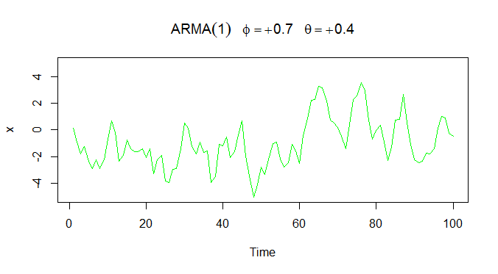

> acfAR1.var=acf(AR1,type="covariance")

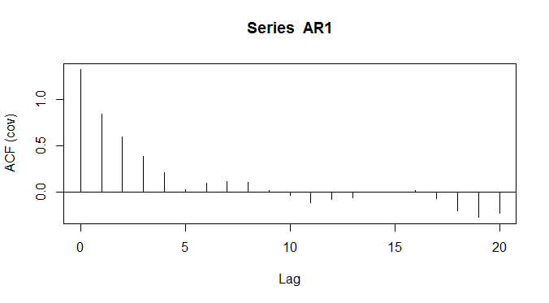

> acfAR1.var

Autocovariances of series ‘AR1’, by lag

0 1 2 3 4 5

1.32165 0.84353 0.59356 0.38553 0.20934

> acfMA1.var=acf(MA1,type="covariance")

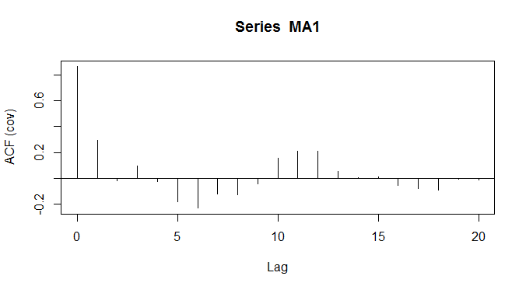

> acfMA1.var

Autocovariances of series ‘MA1’, by lag

0 1 2 3 4 5

0.86280 0.29705 -0.01620 0.09416 -0.02536

> acf(AR1,type="correlation")

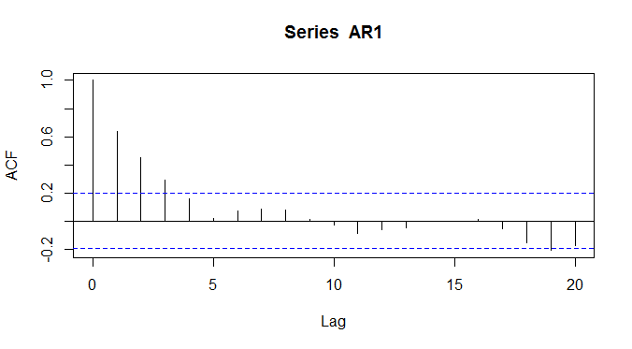

> acf(MA1,type="correlation")

